Knights of Columbus

Alabama Knights on Bikes

Member’s Handbook

**

**In God We Trust and Ride!**

**Adopted 22 October 2022**

**Revised 01 January 2023**

**Revised 01 July 2024**

**TABLE OF CONTENTS**

|  |  |  |
| --- | --- | --- |
| **Who We Are** | **…………………………………………………** | **4** |
| **Our Dedication** | **…………………………………………………** | **4** |
| **Qualifications for Membership in KonB U.S.** | **…………………………………………………** | **4** |
| **Alabama Knights on Bikes Mission** | **…………………………………………………** | **4** |
| **We…** | **…………………………………………………** | **5** |
| **Changes to Handbook** | **…………………………………………………** | **5** |
| **Regularly Scheduled Meetings** | **…………………………………………………** | **5** |
| **State Officers** | **…………………………………………………** | **5** |
| **Election of Officers** | **…………………………………………………** | **6** |
| **Officer Positions** | **…………………………………………………** | **6** |
| **Record Keeping** | **…………………………………………………** | **7** |
| **National Rallies** | **…………………………………………………** | **7** |
| **State, and local Rallies** | **…………………………………………………** | **8** |
| **Alabama Rules** | **…………………………………………………** | **8** |
| **Emblem of the Knights on Bikes - Alabama** | **…………………………………………………** | **8** |
| **Inside the Boundaries of the State, We Find** | **…………………………………………………** | **8** |
| **Clothing / Gear** | |  | | --- | | **…………………………………………………** | | **7** | | **9** |
| **ATGATT** | **………………………………………………….** | **9** |
| **Uniform / Vest Information** | **…………………………………………………** | **9** |
| **Recommended Formal Attire for Knights as Follows** | **…………………………………………………** | **9** |
| **Front / Back Layout for Knights on Bikes Vest** | **…………………………………………………** | **10** |
| **Vest Guidelines, Usage & Formal Attire** | **…………………………………………………** | **11** |
| **Front of Vest** | **…………………………………………………** | **11** |
| **Left Side (as wearing vest)** | **…………………………………………………** | **11** |
| **Right Side (as wearing vest)** | **…………………………………………………** | **11** |
| **Back of Vest** | **…………………………………………………** | **12** |
| **State Long Sleeve T-Shirt** | **…………………………………………………** | **12** |
| **Ladies Vest Guidelines, Usage & Formal Attire** | **…………………………………………………** | **12** |
| **Ladies Front of Vest** | **…………………………………………………** | **12** |
| **Ladies Left Side (as wearing vest)** | **…………………………………………………** | **13** |
| **Ladies Right Side (as wearing vest)** | **…………………………………………………** | **13** |
| **Ladies Back of Vest** | **…………………………………………………** | **14** |
| **Appendix A – Membership Application** | **………………………………………………….** | **15** |
| **Appendix A1 – Release of Liability** | **………………………………………………….** | **18** |
| **Appendix B1 – Al-KoB Central Region Map** | **---------------------------------------------------------** | **19** |
| **Appendix B2 – KoB-USA Map of Regions** | **---------------------------------------------------------** | **20** |
| **Appendix C – Motorcycle Hand Signals** | **---------------------------------------------------------** | **21** |
| **Appendix D – Knights on Bikes Request Form** | **---------------------------------------------------------** | **22** |
| **Appendix E – Knights on Bikes Officers (Current)** | **---------------------------------------------------------** | **23** |
| **Appendix F – Knights on Bikes Officers (Past)** | **…………………………………………………** | **24** |
| **Appendix G – Time Zones / States** | **…………………………………………………** | **25** |
| **Appendix H – KoB Patch Form** | **…………………………………………………** | **26** |
|  |  |  |
|  |  |  |
|  |  |  |
|  |  |  |
|  |  |  |
|  |  |  |

**Knights of Columbus**

**Alabama Knights on Bikes**

**Members Handbook**

# WHO WE ARE

**We are men of “Faith in Action”, who lead, serve, protect, defend, and pray, Knights of Columbus members – First. The Alabama Knights on Bikes is a group of Knights of Columbus members who enjoy motorcycling (2-Wheeled or 3-Wheeled Trike or reverse trike Configuration). Our aim is to support the Order’s principles of Charity, Unity, Fraternity and Patriotism by participating in activities on and off our bike.** **Being a Knight on Bikes member does not preclude us from being an active member of our councils and assemblies. To have a strong Knights on Bikes program we must have a strong council first and foremost.**

**Alabama Knights on Bikes are organized within dioceses as defined by the U.S. Council of Catholic Bishops (USCCB) and the state of Alabama Knights of Columbus. The State of Alabama Knights on Bikes has a State Chairman appointed by the Alabama Knights of Columbus State Deputy. The state has two (Arch) Diocese Coordinators appointed by the Alabama Knights on Bikes Chairman. Each council will have a Council Captain appointed by its Council’s Grand Knight.**

**The State Chairman will appoint other positions to help in the smooth operation of the state KoB. For instance: State Road Captain(s), Secretary/Treasurer, etc. It may be advisable for the State Chairman to confer with Knights of Columbus State Deputy and the Alabama State council for advice when naming these positions. In addition, there will be an elected U.S. National Advisor and four National Regional Vice Advisors (Eastern Region, Central Region, Mountain Region, and Pacific Region)**

**KNIGHTS ON BIKES IS A FRATERNAL ORGANIZATION (WE ARE NOT A MOTORCYCLE CLUB)**

**OUR DEDICATION**

**As Catholic men who are dedicated to serve, protect, and defend in the spirit of patriotism, we strive to become better individuals, husbands, fathers, sons, and neighbors. We are Pro-Life; without Apology, without Compromise, without Exception. We understand and share with others that a child is truly a gift from God our Father. We uplift one another and aspire to exemplify our Catholic faith through the testimonies of our own lives.** **The mission of Alabama Knights on Bikes is to support established programs within the Knights of Columbus State Council and/or local Council or Assembly with permission from the State Deputy and/or Grand Knight and/or Faithful Navigator. Examples: Silver Rose, Special Olympics, ASAP (Aid and Support After Pregnancy) – Pro Life, Rosary Run, Council Membership/Retention, etc.**

**QUALIFICATIONS FOR MEMBERSHIP IN ALABAMA KNIGHTS ON BIKES**

* **Must be a member in good standing with the Knights of Columbus (possess a current membership card)**
* **Submit a completed Alabama Knights on Bikes application to your state Chairman and Coordinator.**
* **Possess a current driver’s license with a motorcycle endorsement of Insurance.**
* **Willing to participate in sanctioned Knights on Bikes events and programs.**

**ALABAMA KNIGHTS ON BIKES MISSION**

1. **Maintain and support the Knight of Columbus’ missions’ goals and recruitment.**
2. **Provide fellowship, brotherhood, and assistance to all its members while enjoying and promoting safety in motorcycle riding.**
3. **The Alabama Knights on Bikes respect, defend, and promote the dignity of human life. By supporting pregnancy center support, marching to defend the unborn and their mothers, helping to end abortion, fundraising for a life-saving ultrasound machine, or escorting and supporting the travels of the “Silver Rose” as it travels throughout Alabama, we are Pro-Life.**
4. **I/A/W Resolution #9, passed at the 2024 Alabama Knights of Columbus State Convention, “Now therefore, be it resolved, that the Alabama State Council identify opportunities for members who ride motorcycles to participate formally in certain state council activities, with details to be worked out by the state deputy in accord with the guidelines provided by the Supreme Council”.**
5. **Assist the Roman Catholic Church, the Bishops of each Diocese, the Knights of Columbus, charitable organizations, individual members, and the community.**
6. **Promote and adhere to the doctrines of the Roman Catholic Church, and evangelize through fellowship, charity, and service.**

***Knights on Bikes are at the service of our Bishops, Priest, and Catholic Parishes!***

**WE…**

* **Enjoy camaraderie with all brothers and councils, spreading the faith and word of the Lord.**
* **Assist the Catholic Church, any Knight, any individual, charity, and the communities in which we live by our charitable work and leadership.**
* **Promote the spiritual needs of our Catholic Church, the Knights of Columbus and encourage, increase, and strengthen our Faith, fellowship, and service.**
* **Are at the service of the Bishops, Priests, and Catholic Parishes.**
* **Support numerous charities through Knights of Columbus fundraising events.**

**CHANGES TO HANDBOOK**

**Each year, any motion to amend these guidelines will be submitted electronically in writing between 1 August and 30 August. Consideration and discussion will occur between the period 1 - 31 September of the current year. The State Officers will render a non-binding opinion on each change with a recommendation of Yes or No vote for each change at the annual Alabama Knights on Bikes state meeting, following the “Little Sisters of the Poor Yard Lawn Party. Each member in good standing who has made at least 4 Council and Assembly meetings will have one vote each. The State Chairman will have one vote that may only be cast to break a tie.**

**REGULARLY SCHEDULED MEETINGS**

**Third Monday of Every Month at 7:00 pm**

**At this meeting, requests for assistance received during the previous month, and any other business matters coming before the council are voted on.**

**ALABAMA STATE OFFICERS**

**SD - Alabama KofC State Deputy SEC / TREAS - (Secretary / Treasurer)**

**SC – State Chairman ACB - Archdiocesan Coordinator for Mobile DCB – Diocese Coordinator of Birmingham**  **CC - (Council Captain)**

**ELECTION OF OFFICERS**

**Nominations and appointment of all Alabama Knights on Bikes officers will be on the same time schedule as election of Alabama Knights of Columbus Council officers. All officers are appointed for a two-year term. The Alabama Knights of Columbus State Deputy will appoint the Alabama Knights on Bikes State Chairman. The Alabama Knights on Bikes Chairman will appoint the Archdiocesan Coordinator of Mobile and the Diocesan Coordinator of Birmingham at the State KofC Convention. The council’s Grand Knights will appoint Council Captains. Road Captains will be voted in by state memberships. Officers will assume their office on July 1.**

**In the event there is a vacancy in an elected position that is more than 4 months from regular elections, a special election for the position vacated will occur using the same process, time frames and procedures as the regular election for that position.**

**OFFICER POSITIONS**

**State Deputy  -** **The Alabama Knights of Columbus State Deputy aim is to support the Order’s principles of Charity, Unity, Fraternity and Patriotism by participating.**

**State Chairman  -** **The Alabama Knights on Bikes State Chairman’s** **aim is to support the Order’s principles of Charity, Unity, Fraternity and Patriotism by participating in activities on and off the bike. He is responsible for setting Alabama Knights on Bikes goals under the direction of the Alabama Knights of Columbus State Deputy and ensuring that all officers fulfill their duties in reaching these objectives. He presides over all state meetings; appoints program directors as needed.**

**Diocesan Chairman (Mobile) -** **The Diocesan Chairman (Mobile) serves as the State Chairman's assistant and fills in for the State Chairman when he is not present. Ultimately, he assists the State Chairman in leading the state and assist in recruiting and retaining members and to this end he should is responsible for events in the Archdiocese of Mobile that display the values and principles of the Knights of Columbus.**

**Diocesan Chairman (Birmingham) - The Diocesan Chairman (Birmingham) fills in for the State Chairman and Diocesan State Chairman (Mobile) when both are not present. Ultimately, he assists the state Chairman in leading the state and assist in recruiting and retaining members and to this end he should is responsible for events in the Diocese of Birmingham that display the values and principles of the Knights of Columbus.**

**Secretary / Treasure  - The Secretary / Treasure has the responsibility of recording all meetings and events held by the group and managing any money received and transferring said money raised to the KofC State Treasurer. He should record minutes, conversations, and other information helpful to the group and prepare them to be distributed to the membership in a timely manner. Additionally, he should help with group event notifications, meeting reminders, and assist with council social media responsibilities.**

**Chaplain - The Chaplain is the spiritual leader of the group. He nurtures faith in members particularly through the sacraments but also through spiritual direction, retreats and other events and support.**

**Deacon - The Deacon helps the Chaplain in nurturing our faith in members particularly through the sacraments but also through spiritual counseling.**

**Membership Director - The membership director serves as the head of the Admission Committee and works to grow the group`s membership through new and transfer members and works to keep the members active. implements programs and practices that provide mentors for new members and regularly communicates with the members to encourage their participation.**

**Road Captain** - **The Road Captain(s) is responsible for all Alabama Knights on Bikes runs, while serving as Road Capitan for a designated ride. He shall research, plan, and organize all the runs. The Road Captain is also responsible for knowing the states that the group will be venturing into. The six things that every Road Captain should know about every member of their group are their name, home address, emergency contact person, phone number, current medication, and known allergies. This information should be generated by the Road Captain but carried by several members throughout the formation,**

1. **Know Hand Signals. (Appendix C)**
2. **Hold a Pre-Ride Meeting.**
3. **Select a Group Lead and Sweep.**
4. **Keep Your Group’s Size Manageable.**
5. **Stagger Your Riding Formation.**

* **Stay Aware of Your Group’s Riders While on the Road. Road Captains must have motorcycle**

**riding experience and have taken and have passed an advanced riding course of level 2 or higher, (Not required for 3 wheel Trikes). Road Captains can be removed by the Alabama Knights on Bikes Chairman if they are unable to complete the responsibilities as outlined. The number of Road Captains may be adjusted as needed by the Alabama Knights on Bikes Chairman. The Road Captains must have excellent communication and planning ability. They are responsible for making sure all members have a current license and Insurance. Road Captains will also be responsible for all planning and execution on all rides in their area.**

**RECORDS KEEPING**

**It is the responsibility of the State Chairman to maintain a list of members (census) within the state and to periodically confirm that Alabama Knights on Bikes members are members in good standing with Knights of Columbus. The census may be shared with the Knights on Bikes – USA Regional Advisor when required for status verification.**

**There will be NO separate Knights on Bikes dues.**

**Alabama Knights on Bikes at any level will not maintain any bank accounts. All money will be managed by local or State Council officers per KofC Constitution and Rules.**

**NATIONAL BI-ANNUAL RALLIES**

**There will be a bi-annual nationwide Knights on Bikes Rally on the odd numbered years. This will be open to all Knights on Bikes members, spouses, and guests. The rally will be a celebration of accomplishments and an opportunity for fellowship of Knights on Bikes from all over the world. The primary business that should occur at this rally is a vote on where the next rally should occur.**

**Alabama Knights on Bikes members may attend out of state rallies, only when invited by that state’s leadership.**

**STATE, and LOCAL RALLIES**

**It is recommended that each State and/or Diocese conduct a local rally when appropriate. The idea is to involve members that would/could not attend a bi-annual rally.**

**ALABAMA RULES**

1. **At all times Alabama Knights on Bikes members will keep in good Standing of in their local Knights of Columbus Council.**
2. **If a member is found to be conducting themselves in a manner that violates the exacting standards and rules of the Knights of Columbus, the local Grand Knight, District Deputy, the Alabama Knights of Columbus State Deputy, and the Alabama State council will be notified.**

**All forms of discipline will be managed under the Knights of Columbus rules and regulations.**

1. **AT NO TIME will a Knights on Bike member interfere with a Knights of Columbus Programs to include the 4th degree.**
2. **Alabama Knights on Bikes members who wish to join the Color Crop can only do so in 4th Degree Regula, no exceptions. If the rule is broken, a report will be sent to the 4th Degree Master and State Deputy.**

* **If asked, the Knights on Bike may join the procession.**
* **Knights on Bike members will not ask to join the procession, they must be invited.**
* **Requests are to be made from Grand Knight, Faithful Navigator, or the Knights of Columbus State Deputy.** 
  + **The Alabama Knights on Bikes request form must be filled out in advance with approval from local Alabama Knights on Bikes Council Captain, (Arch) Diocese Coordinator, and Alabama Knights on Bikes State Chairman.**
  + **Knights on Bike members will follow the Color Corp, bow, and then take their seats. They may not stand with the Color Corp.**

**EMBLEM OF THE ALABAMA KNIGHTS ON BIKES**

**The emblem of the Alabama** **Knights on Bike group was designed in October 2022 and reflects our beliefs.**

* **A picture containing text, queen

  Description automatically generatedAt the top of the emblem is a pair of hands clasped in a handshake, enclosed in a heart. The handshake, which symbolizes meeting, greeting, parting, offering congratulations, expressing gratitude, or as a sign of good sportsmanship. Its purpose is to convey trust, respect, balance, and equality. The red heart symbolized our shared love and respect in our Lord and Our God.**
* **The map of Alabama is a visual representation of our state borders and that we serve our entire state.**

**INSIDE THE BOUNDARIES OF THE STATE, WE FIND**

**The emblem of the order dates to May 12, 1883, when it was designed by James T. Mullon, then the first Supreme Knight. A quick glance at the emblem indicates a shield, mounted on a cross of Malta. The shield is associated with a medieval knight. The cross of Malta is the representation in a traditionally artistic design of the Cross of Christ, through which all graces of redemption are procured for mankind. This, then, represents the Catholic spirit of the Order. Mounted on the shield are three objects; a mace standing vertically, and crossed behind it, an anchor, and a dagger or short sword. The mace from the Roman days is symbolic of authority, the anchor is the mariner's symbol of Columbus, patron of the Order, while the short sword or dagger was the weapon of the knight when engaged upon an errand of mercy. Thus, the shield expresses Catholic Knighthood in organized merciful action with the letters K of C, it proclaims the specific form of activity.**

**Located below the emblem of the Knights of Columbus group, is the Knights on Bikes emblem. The emblem depicts the initials, K & B with a cross of Christ position on top, circled by our name and our watch words. This is all enclosed in a never-ending circle.**

**Located under the state of Alabama map are the initials IGWTAR, the group’s motto – “In God We Trust and Ride”**

**On October 20, 2022, the Alabama Knights of Columbus State Deputy approved the establishment of the Alabama Knights on Bikes Motorcycle Ministry, to be recognized as an approved Alabama Knights of Columbus activity for all Alabama Knights who** **ride motorcycles.**

**Saint Francis once said, “Evangelize often, and sometimes use words.”**

**Brother Knights spread the Faith by riding together for Christ. Alabama Knights on Bikes is a Catholic Motorcycle Ministry who “Trust in God and Ride” in support of Alabama Knights of Columbus Council’s Faith in Action programs and events across the state**

## **CLOTHING / GEAR**

**On a sanctioned (casual) ride, we wear the State long sleeve shirt with black vest (with appropriate patches) and blue/black jeans.  For rides that include attending Mass or other formal events you will wear the official dress attire to include Alabama Knights on Bikes Vest, White long-sleeved shirt, black pants, black belt, and black shoes or boots that cover the ankles.**

**Note: All members of whose vest was approved prior to these guidelines are grandfathered in until said vest is no longer serviceable.**

**ATGATT**

**ATGATT – All the Gear, All the Time. We highly encourage everyone to wear safety gear for all the rides. Full gear including DOT, ECE, Snell, SHARP, or FIM approved helmet, jacket (when needed), above the ankle boots, gloves, and rain suit (when needed) is encouraged. Please remember you are always a catholic gentleman and are representing the Knights of Columbus and as such you will not wear any clothes, gear or patches with any inappropriate language or images.**

**UNIFORM / VEST INFORMATION**

**No one will be required to wear the vest at all times, even when riding, whether alone or in groups. It shall be at the rider’s own discretion. It should be worn while participating in any Alabama Knights on Bikes rides or functions. Unless otherwise instructed by State Chairman, or if weather is over 90 degrees. The Vest may also be worn to any church Mass or KofC functions, even if you are not riding at said time.**

**RECOMMENDED FORMAL ATTURE FOR**

**ALABAMA KNIGHTS ON BIKES AS FOLLOWS**

**1. Full Alabama Knights on Bikes Formal Attire/Dress -- White collared long sleeved dress shirt under “Knights on Bikes” Vest; State Long Sleeve Riden Shirt (Kelly Green); White-Gloves (Only when handling the Silver Rose); Black pants (black-denim optional); Black Belt (optional); and above the ankle shoes or boots,**

1. **The wearing of “Knights on Bikes” Formal Attire/Dress is a visual way for people to identify the “Knights on Bikes” members at events.**
2. **It separates us from any other motorcycle group and “sets us apart” (which is the definition of being holy: to be set apart for sacred purpose). It also allows us to evangelize without words, as many people immediately recognize us as Catholic, and as Knights of Columbus, and as Members on motorcycles who do charity and works for the Catholic Church, the community, and its membership.**
3. **The Alabama Knights on Bikes member who is wearing the Formal Attire/Dress may attend the function along with the 4th Degree Honor Guard is participating in, BUT NOT AS PART of the 4th Degree Honor Guard during the formal event, and only with the permission and direction of the Honor Guard Commander.**
4. **When we ride as a group. Many times, we ride as we are, with just our vests. But can and are encouraged to wear our formal attire during dedicated events while being seen at public community events (such as Christmas Parades).**
5. **Priests will wear a black long/short sleeved clerical shirt; Deacons will wear blue in lieu of the white shirt.**
6. **Since it is purely optional for the ‘Alabama Knights on Bikes” member to have the “****Knights on Bikes” vest, the Formal Attire/Dress is SUGGESTED, but IT IS NOT MANDITORY and IS PURLEY OPTIONAL for our “Knights on Bikes” members.**
7. **It is not mandated that anyone be obligated to follow the “Knights on Bikes” Formal Attire rules if he does not possess the “Knights on Bikes” Formal Attire.**

**PURPOSE OF PATCHES FORMS REQUEST**

* + **To ensure that only approved/current Alabama Knights on Bikes members order the Alabama Knights on Bikes Crests.**
  + **To maintain integrity of size, color, and shape of Alabama Knights on Bikes Crests.**

**Only one Order Form per member.**

* 1. **Crest Order form will be filled in manually, the Order form is available from the State Chairman.**
  2. **Crest Order Form will be validated by the Coordinator of the (Arch) Diocese, or designated representative of the Alabama Knights on Bikes.**
  3. **All Order Forms shall be validated with current State Member Rosters.**
  4. **Order Forms for New Members shall include an approved Membership Form to ensure that the members is included in the Alabama Knights on Bikes Database.**
  5. **Members approved request with payment will be sent to the National Supplier.**

**No member of Alabama Knights on Bikes will wear the Alabama Knights on Bikes Vest or emblems at any event or situation that is not in keeping with the good name of the Knights of Columbus or Knights on Bikes.**

**VEST GUIDELINES, USAGE & FORMAL ATTIRE**

**The Base Material of the Alabama Knights on Bikes Vest will be as follows:**

**1. Black Leather, or Black denim cloth, or Black Textile. All patches must be in good taste and befitting a Catholic gentleman.**

**Official Location and or Placement of all and any Crests on Alabama Knights on Bikes Vest shall be;**

**FRONT OF VEST**   
**LEFT SIDE (as wearing vest)**

1. **National Flag - Left Side above the Small Knights of Columbus Emblem,** 
   1. **Military Veteran may add the “Veteran” patch below the flag,**
2. **Small Knights of Columbus Crest - {4 inch} below the National Flag )Veterans patch,**
3. **Fourth Degree Emblem – below the Knights of Columbus Emblem,**
4. **Any Former or Past or Official Recognized Knights of Columbus Position Crest. below,**

**RIGHT SIDE (as wearing vest)**

1. **Knights on Bikes Officer or Past officer position patch rockers placed above State flag,**
2. **Alabama State Flag – In line with the National Flag.**
3. **Alabama Knights on Bikes “Diocesan Crest” Patch, Below the Alabama Flag,**
4. **“Silver Rose” Escort Patch - Authorized for current or former members of the designated state Alabama Knights on Bikes “Silver Rose” escort team, below** **“Diocesan Crest” Patch,**
5. **“7/8 Inch- Long Stem White Rose Lapel Pin, worn above the Silver Rose Escort Patch, to denote completed an escort mission (One per Fraternal Year)**
6. **Tempus Fugit Patch or Vatican Patch, Below the “Silver Rose Escort patch (if authorized),**
7. **Patches as approved by the Alabama Knights of Columbus State Deputy and Alabama Knights on Bikes State Chairman, and shall be in keeping with the good of the Order and upon,**
8. **Any other suitable or appropriate patch/crest may be affixed to the FRONT of the vest at any location other than what is described above.**
9. **Patches worn must be in good keeping with the Knights of Columbus. Always remember that you are a Catholic Gentleman and a member of the Knights of Columbus, first and always.**

**Members are encouraged to wear the Knights on Bikes vest as much as possible.**

**FRONT OF VEST**

**(Sample)**

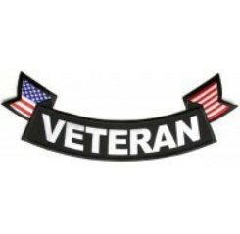

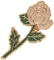

* A close-up of a badge

  Description automatically generated with low confidenceA picture containing text, clipart

  Description automatically generated**Silver Rose Escort**

**Team Only**

**Personal Patch**

**Personal Patch**

**BACK OF VEST**  
**Top Center -** **Gold Cross – On Back between the shoulder blades,**  
**Large Knights of Columbus Crest - {not smaller than twelve inches} be centered from lower part of cross and the bottom of the vest, a reflective patch, worn below the KofC patch is authorized.**

**There shall be NO ADDITIONAL CRESTS, LOGO, etc. shown on the BACK of the VEST.**

**Note: It will be the responsibility of the Alabama Knights on Bikes State Officers to ensure vests and patches are within Alabama Knights on Bikes Guidelines for their jurisdictions.**

**ALABAMA Knights on Bikes MEMBERS RIDING SHIRT**

1. **A green long sleeved shirt

   Description automatically generatedMembers are encouraged to wear the state riding under their vest while riding,**
2. **The riding shirt is a Kelly green, long sleeve T - Shirt with the Alabama Knights on Bikes State logo on the left chest and Knights on Bikes spelled out on the Right Sleeve.**

**LADIES VEST GUIDELINES, USAGE & FORMAL ATTIRE**

1. **Wives / Girlfriends of Members are encouraged to participate and ride with the Member,**
2. **The Ladies “Knights on Bikes” members may wear a vest of leather, textile, or cloth in the color of their choice. Vest can be obtained and made up for the lady, the “Ladies Crest Packet” may be purchased from the Designated National Supplier,**
3. **The “Ladies Crest” shall be organized and placed in the same manner as the Membership Crest Packet obtained and installed by the member himself.**
4. **Large circular crest on the back in lieu of the large “Emblem of the Order,”**
5. **The smaller Ladies Crest in lieu of the member’s Diocesan Crest,**
6. **At NO TIME Shall the “Emblem of the Order” be placed on the Ladies Vest,**

***All patches must be in good taste and befitting a Catholic Lady.***

**Location and or Placement of all and any Crests on Knights on Bikes Vest shall be;**

**LADIES FRONT OF VEST** 

**LEFT SIDE (as wearing vest)**

**National Flag - Left Side above the Small Knights of Columbus Emblem,**

1. **Military Veteran may add the word “Veteran” below the flag, for display,**

**RIGHT SIDE (as wearing vest)**

1. **Alabama State Flag – In line with the National Flag,**
2. **“Silver Rose” Escort Patch - Authorized for current or former members of the state designated KoB “Silver Rose” escort team Only.**
3. **“Silver Rose” lapel Pan - One pin authorized to denote completed escort mission (1 - FY).**
4. **Vatican Patch,**
5. **Patches as approved by the Knights of Columbus State Deputy and State Chairman and shall be in keeping with the good of the Order.**
6. **Any other suitable or appropriate patch/crest may be affixed to the FRONT of the vest at any location other than what is described above.**
7. **Other patches may be worn that are in good keeping with the Knights of Columbus.**

**Ladies are encouraged to wear the Alabama Knights on Bikes vest as much as possible.**

**LADIES FRONT OF VEST**

**(Sample)**



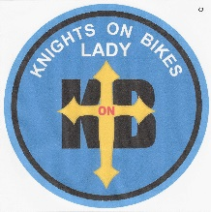

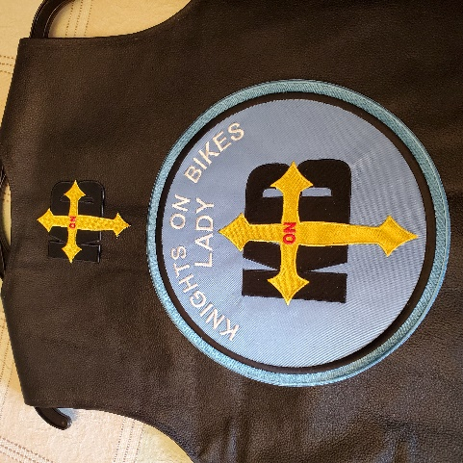

* **Silver Rose Escort**

**Team Only**

**Personal Patch**

**Personal Patch**

**LADIES BACK OF VEST**  
**Top Center -** **Gold Cross – On Back between the shoulder blades,**  
 **Large Knights on Bikes Ladies Patch - {10 inches} shall be centered from**

**lower part of cross and the bottom of the vest. The Patch will say “Knights on Bikes Lady.”**

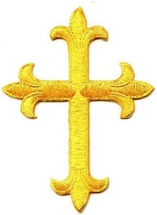

**There shall be NO ADDITIONAL CRESTS, LOGO, etc. shown on the BACK of the VEST.**

**Note: It will be the responsibility of the Alabama Knights on Bikes State Officers to ensure vests and patches are within Alabama Knights on Bikes Guidelines for their jurisdictions.**

**For the items that are not covered in our Guidelines please refer to the Knights of Columbus Constitution and Laws of the Order. We will defer to the Knights of Columbus Constitution and Laws of the Order on how to conduct ourselves when wearing the emblem of the order.**

**APPENDIX A**

**ALABAMA KNIGHTS ON BIKES**

**MEMBERSHIP APPLICATION**

**Full Name: ____________________________________ Sir Knight: Yes _____ / No ______**

**Address: ______________________________ City: _________________ St:______ Zip: ___________ Top of Form**

**Cell #: ________________ Home #: _______________ e-mail: __________________________________**

**Road Name: ______________ Spouse Name: ______________ Spouse Road Name: ______________**

**(If Applicable) (If Applicable)**

**I currently own a properly register and licensed motorcycle or plan to own one in 6 months Yes _____**

**Parish: ______________________ City: ___________________**

**Please include a copy of your Knights of Columbus Travel (Membership) Card on back of Application.**

**(PLACE HERE)**

**(Arch) Diocese: _______________________________________**

**KofC Member, in Good Standing: Yes _____ / No ______**

**KofC Membership #: _________________**

**KofC Council Name: ____________________________________ KofC Council #: _________________**

**KofC Assembly Name: _________________________________ KofC Assembly #: _________________**

**Current Council / Assembly / State Office Position: __________________________________________**

**Do you know any Knights who wish to join the Knights on Bikes program: Yes _____ No _____**

**How did you learn about the Knights on Bikes program? ____________________________________**

**Please review our handbook. It is important that you understand and accept the policies of the Knights on Bikes program. We must be a Knight in good standing with our Knights of Columbus Councils and be regular participants in the Catholic mass. It helps us to be united as Catholic gentlemen as we represent Christ, the Holy Catholic Church and the Knights of Columbus. We must always carry ourselves as and remember that we are Catholic gentlemen and embrace our Catholic faith for the world to witness. Please contact the Alabama State President, with any questions that you may have. We ask that you take a moment and pray, reflect, and share your ideals with anyone in your family prior to proceeding with this application. It is important that our families and our faith are with us in all that we do. We are not a Motorcycle Club or Motorcycle Organization, ect. We are members of the Knights of Columbus who enjoy riding motorcycles and nothing more.**

**Have you read and understood the Knights on Bikes Handbook? Yes _____ / No _____**

**If the information on this application is complete and honest and you wish to join us?**

**Please sign the application:  __________________________________ __________________**

**SINGATURE DATE**

**APPENDIX A-1**

**Please Include a copy of your Knights of Columbus Travel / Membership Card Below**

**Send To:**

**ALABAMA KNIGHTS ON BIKES**

**STATE COORDINATOR**

**SK John L. Blackburn**

**2094 Lakeview Road**

**Ozark, Al 36360**

**334-714.0167**

**kofcalkob@gmail.com**

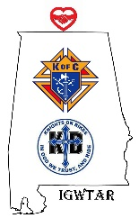**APPENDIX A-2**

**RELEASE OF LIABILITY**

**COVENANT NOT TO SUE, WAIVER AND AGREEMENT**

**By signing this agreement, I acknowledge that I understand that motorcycle riding and touring is hazardous and may result in severe injury or death. I understand that this activity in which I am voluntarily participating in has inherent risks (including death, loss of limb and permanent disability, and damage to or loss of property) that I assume.**

**I certify that I am duly licensed, insured, and competent to operate a motorcycle in a safe manner and the vehicle I will be operating during the tour/event is in safe and legal operating condition. I am solely responsible for determining the speed and operational characteristics of my motorcycle and my ability as a motorcycle operator while participating in the event.**

**I hereby agree to expressly and voluntarily accept and assume all risks involved in operating a motorcycle or participating as a motorcycle passenger while participating in an event with KNIGHTS OF COLUMBUS / KNIGHTS ON BIKES.**

**I hereby covenant, as a motorcycle operator or motorcycle passenger, not to sue Knights of Columbus / Knights on Bikes, their agents, employees, officers, directors, managers or representatives for any and all loss or damage including property damage or loss, personal injury, permanent disability and/or death, arising out of my participation in any Knights on Bikes activity (including but not limited to riding, touring, transportation to and from the activity, and at all lodging and stops).** **Knights of Columbus / Knights on Bikes makes no warranty regarding conditions, safety of roadways, weather, lodging or stops, and I assume all risk that the conditions, safety of roadways, weather, lodging, or stops are other than what is expected.**

**I understand and agree that KNIGHTS OF COLUMBUS / KNIGHTS ON BIKES is acting as my agent only to provide guidance as to routes, and to obtain meals along the route, and I hereby release and hold harmless KNIGHTS OF COLUMBUS / KNIGHTS ON BIKES its owners, agents, assigns and heirs against any and all claims, causes of action, or any other liability of any kind arising from my operation of a motorcycle or as a motorcycle passenger during my activity of motorcycle events. By signing this agreement, I agree to abide by all event requirements regarding safe and legal operation of motorcycles, no use of drugs and agree that any violation of these requirements will result in the termination of my participation in the tour without recourse or refund. I certify that I have no known physical or mental impairment that may affect my safety or the safety of the group. I understand that subsequent to state and local regulations, the choice of wearing a helmet or other protective gear is solely my own and that KNIGHTS OF COLUMBUS / KNIGHTS ON BIKES most strongly recommends its event participants to wear protective gear.**

**Further, I certify that I am not under the influence of alcohol, any narcotic, or other drug that may impair my understanding or judgment. By signing this agreement, I acknowledge that I have read this liability waiver and agreement and that I am waiving any claim as set forth herein for myself, my spouse, personal representatives, assigns, heirs and next of kin. In consideration of being permitted to participate in the event,**

**I hereby release, waive, hold harmless, discharge, and agree to indemnify KNIGHTS OF COLUMBUS / KNIGHTS ON BIKES, their owners, agents, employees, officers, directors, managers and representatives from any and all liability to me, my spouse, personal representatives, assigns, heirs and next of kin for any and all claims, demands, liability, loss or damage (including property damage or loss, personal injury, permanent disability and/or death), in any way resulting from or arising in connection with this activity. I hereby agree to fully assume the risk and full responsibility of bodily injury, permanent disability, death, or property damage due to the negligence of those being released herein, and on behalf of myself, my spouse, my personal representatives, assigns, heirs and next of kin.**

**I acknowledge and agree that there are inherent risks of serious bodily injury and/or death and the purpose of this liability waiver and agreement is to be as broad and inclusive as permitted by the law of the state of Alabama and that if any portion hereof be held invalid, I do expressly agree that the balance shall notwithstanding, continue in full legal force and effect.**

**I further agree to the irrevocable and unrestricted right to use and publish photographs of me, or in which I may be included, for editorial trade, advertising, and any other purpose and in any manner and medium.**

**I, the undersigned, have read and voluntarily signed this Release of Liability, Covenant Not to Sue, Waiver & Agreement.**

**Printed Name: __________________________________ Date: ________________**

**Check One: Rider ____ Passenger ____ E-Mail: __________________________**

**Signature: ____________________________________________________________**

**Address: ___________________________________ City: ____________________**

**State: _______________ Phone: ___________________________**

**APPENDIX B-1**

**APPENDIX B-2**

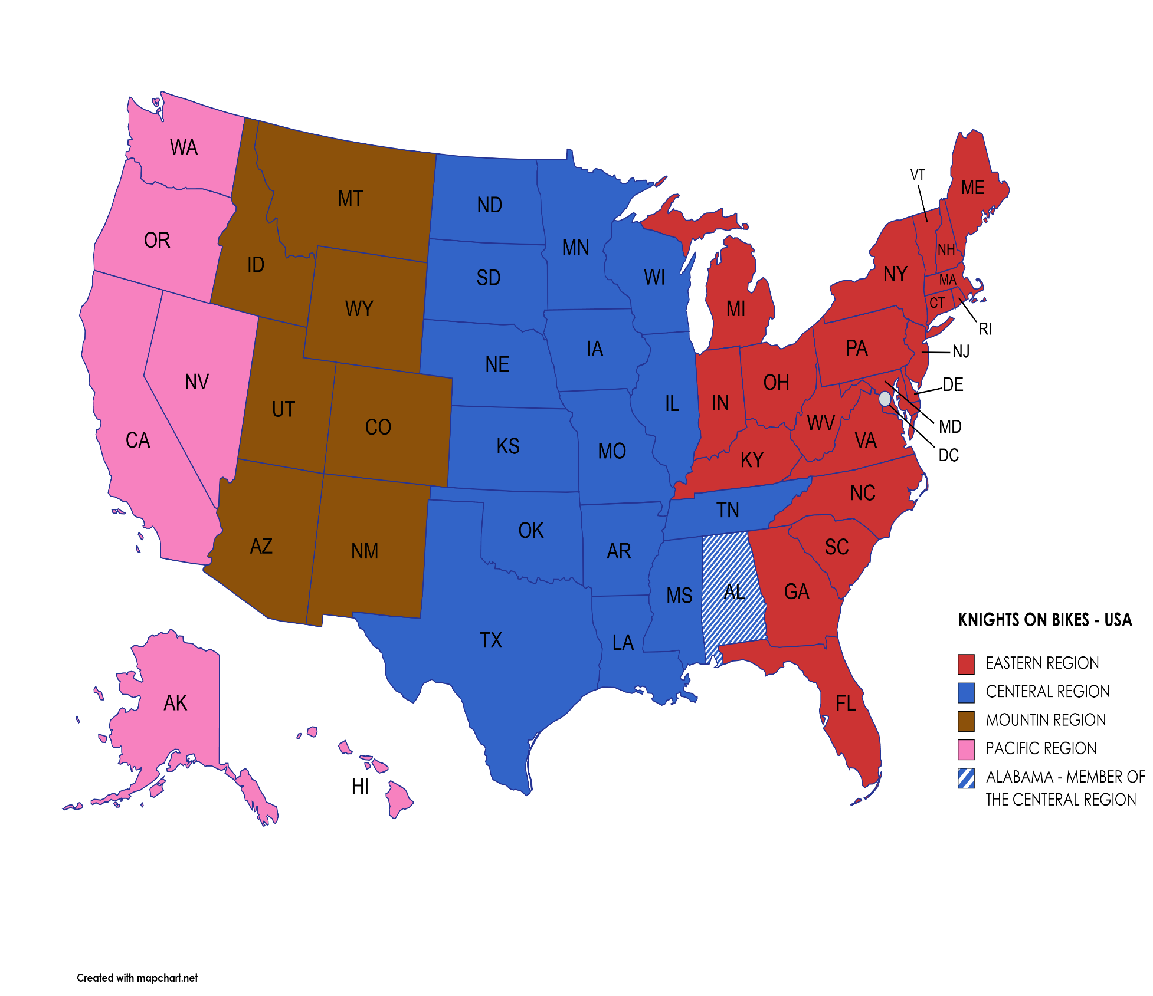

**APPENDIX C**

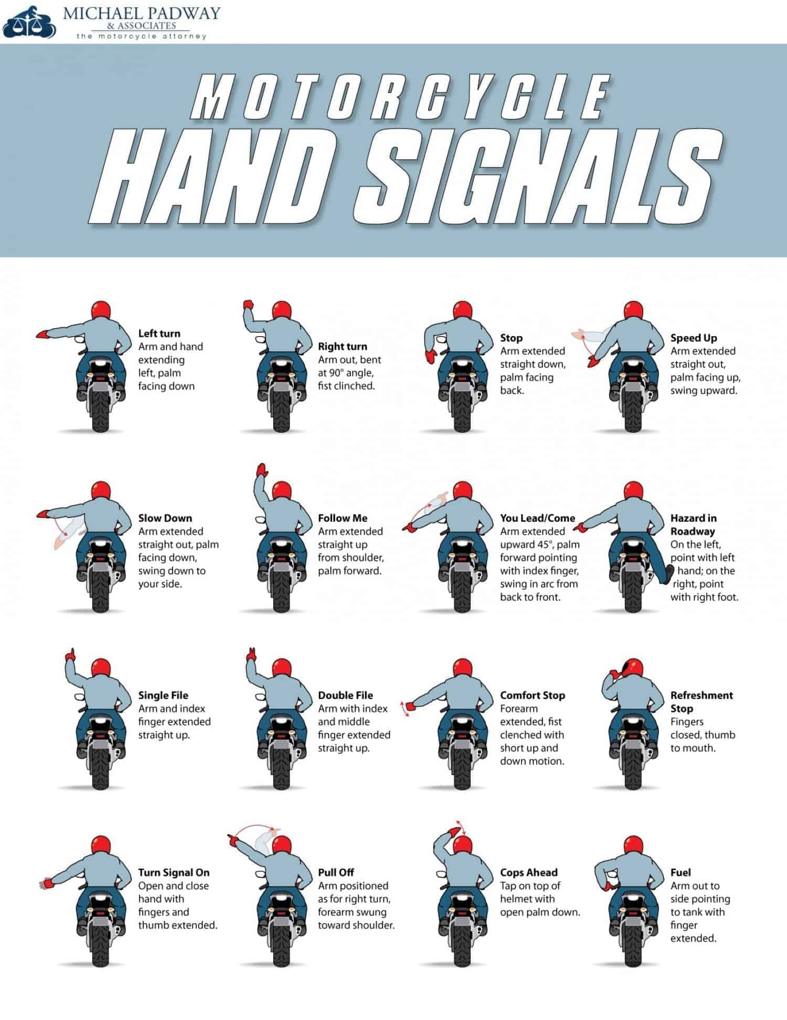

**Appendix D**

**ALABAMA KNIGHTS ON BIKES REQUEST FORM**

**Parish: __________________________________________________________________________**

**Parish Priest Notes/Concerns: ______________________________________________________**

**Nature of Request: Precession: ____ Escort: ____ Rosary:____ Ride: ____ Other: _______**

**Explain: ______________________________________________________________________________**

**Request By: ____________________________ Event Date: ______________________________**

**Event Location: _________________________ Assembly/Council: ________________________**

**CONTACT INDORMATION:**

**Name: __________________________________ Signature _______________________________**

**Phone ______________ Email _____________________ Date:________________**

**Council** **Captain: __________________________________________________________________**

**Met with Requesting party: YES NO Notes: ______________________________________**

**Road Captain: ____________________________________________________________________**

**Council Captain Notified Date: _______________________**

**Alabama Knights on Bikes Call out Send date time: ________________**

**Alabama Knights on Bikes Chairman: _____________________________________________**

**Approved: YES NO**

**Appendix E**

**Alabama Knights on Bikes**

**Current State Officers and Council Captains**

**As of: 01 July 2024**

**STATE OFFICERS**

|  |  |  |  |
| --- | --- | --- | --- |
| **POSITION** | **NAME** | **AREA** | **HOME CITY** |
| **SD - Alabama State Deputy** | **SK Bill Mores** | **State of Alabama** | **Huntsville** |
| **SC – State Chairman** | **SK John Blackburn** | **State of Alabama** | **Ozark** |
| **ACB - Archdiocesan Coordinator for Mobile** | **SK Dwayne Tippery** | **Archdiocese of Mobile** | **Mobile** |
| **DCB – Diocese**  **Coordinator of Birmingham** | **SK Lee Donaldson** | **Diocese of Birmingham** | **Huntsville** |
| **SCH – State Chaplain** | **VACANT** | **State of Alabama** | **N/A** |
| **SDCN – State Deacon** | **Deacon Paul Keil** | **State of Alabama** | **Huntsville** |
| **SEC - Secretary** | **SK Brandon Blackburn** | **State of Alabama** | **Ozark** |
| **RC – Road Captain** | **Vacant** |  |  |

**COUNCIL CAPTAINS**

|  |  |  |  |
| --- | --- | --- | --- |
| **COUNCIL #** | **(ARCH) DIOCESE** | **COUNCIL CITY** | **NAME** |
| **5636** | **Mobile** | **Ozark** | **SK John Blackburn** |
| **7270** | **Mobile** | **Mobile** | **SK Dwayne Tippery** |
| **17519** | **Birmingham** | **Huntsville** | **SK Lee Donaldson** |
| **16172** | **Birmingham** | **Huntsville** | **Deacon Paul Keil** |
| **1019** | **Savannah** | **Phenix City** | **SK Robert Boehnlien** |
| **13125** | **Mobile** | **Mobile** | **SK William Dixon IV** |
|  |  |  |  |
|  |  |  |  |
|  |  |  |  |
|  |  |  |  |
|  |  |  |  |

**Appendix F**

**Alabama Knights on Bikes**

**Past State Officers and Council Captains**

**As of: 01 July 2024**

**2022 – 2024 STATE OFFICERS**

|  |  |  |  |
| --- | --- | --- | --- |
| **TO - FROM** | **POSITION** | **NAME** | **AREA** |
| **2022 - 2024** | **SD - Alabama State Deputy** | **SK Danny Garcia** | **State of Alabama** |
| **SC – State Chairman** | **SK John Blackburn** | **State of Alabama** |
| **CODM - Chairman of Diocese (Mob)** | **SK Dwayne Tippery** | **Archdiocese of Mob** |
| **CODB - Chairman of Diocese (Bhm)** | **SK Lee Donaldson** | **Diocese of Bhm** |
| **SDCN – State Deacon** | **Deacon Paul Keil** | **State of Alabama** |
| **SEC – Secretary** | **SK Brandon Blackburn** | **State of Alabama** |

**Appendix G**

**Alabama Knights on Bikes**

**Regions / States**

|  |  |  |  |
| --- | --- | --- | --- |
| Eastern Region States | **Central Region States** | Mountain Region States | Pacific Region State |
| Connecticut | **Alabama** | Arizona | Alaska |
| Delaware | **Arkansas** | Colorado | California |
| Florida | **Illinois** | Idaho | Nevada |
| Georgia | **Iowa** | Montana | Oregon |
| Indiana | **Kansas** | New Mexico | Washington |
| Kentucky | **Louisiana** | Utah | Hawaii |
| Maine | **Minnesota** | Wyoming |  |
| Maryland | **Mississippi** |  |  |
| Michigan | **Missouri** |  |  |
| New Hampshire | **Nebraska** |  |  |
| New Jersey | **North Dakota** |  |  |
| New York | **Oklahoma** |  |  |
| North Carolina | **South Dakota** |  |  |
| Ohio | **Tennessee** |  |  |
| Pennsylvania | **Texas** |  |  |
| Rhode Island | **Wisconsin** |  |  |
| South Carolina |  |  |  |
| Vermont |  |  |  |
| Virginia |  |  |  |
| West Virginia |  |  |  |
|  |  |  |  |

**Appendix H**

**Alabama Knights on Bikes**

**Patches for Vest Forms**

**Appendix H**

**Alabama Knights on Bikes**

**Patches for Vest Forms**

