WHO ARE KNIGHTS ON BIKES?

WE ARE…
…God Loving…Catholic Men…Single…Married. …Husbands…Fathers. …Brothers…Knights of Columbus…A Fraternal Organization…KofC Members Who Own & Ride Motorcycles
Changing the way
many view Bikers.… Difference Makers.

WE BELIEVE IN SERVING…
…Our God …Our Faith.… Our Families.… Our Communities.
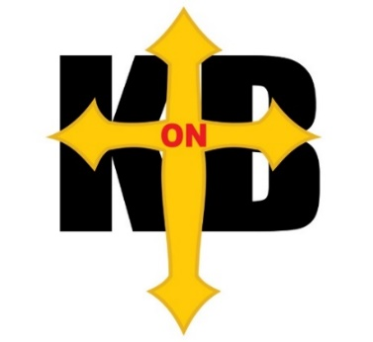

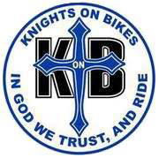

WE ARE NOT…
…A Biker Gang or… A Motorcycle Club (MC).

OUR MOTTO IS SIMPLE…
IN GOD WE TRUST AND RIDE!

We are Men who live: “Faith in Action” Who Lead, Serve, Protect, Defend and Pray
To learn more about KonB in Alabama or request more information, E-mail: kofcalkob@gmail.com

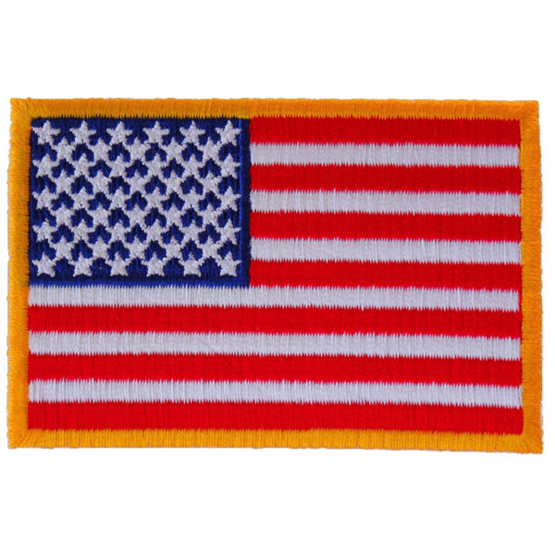

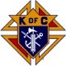

ALABAMA

KNIGHTS ON BIKES

Serving the Knights of Columbus in the Archdiocese of Mobile & Diocese of Birmingham

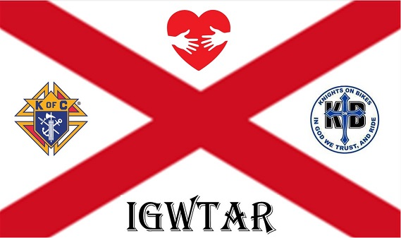

Welcome to Knights on Bikes

We invite you to join us and members of the Knights of Columbus and be a member of the “Alabama Knights on Bikes”. It has been said that - “The ultimate brotherhood is being a Knight of Columbus. Being a member of Knights on Bikes is the cherry on top!” We proudly wear a vest that clearly promotes the Knights of Columbus organization

Who We Are
Knights on Bikes is a group of Knights of Columbus members who enjoy motorcycling. Our aim is to support the Order’s principles of Charity, Unity, Fraternity and Patriotism by participating in activities both on and off our bikes. through the testimonies of our own lives.

The Silver Rose
The “Silver Rose” icon will be the centerpiece of prayer services and mass in parishes across the great state of Alabama during the period September 03 through October 03. The program is sponsored by the Alabama Knights of Columbus (Life, Silver Rose Committee) to honor Our Lady of Guadalupe and express both international unity and dedication to the sanctity of human life. The Knights on Bikes are Honored to serve as Escorts, as it enters and leaves Alabama.

Our Dedication
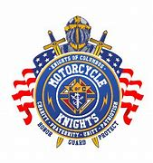
As Catholic men dedicated to serve, protect, and defend in the spirit of patriotism, we strive to become better individuals, husbands, fathers, sons, neighbors, we uplift one another and aspire to exemplify our Catholic faith through the testimonies of our own lives.

We

- Enjoy camaraderie with different brothers and councils, spreading the faith and word of the Lord.
- Assist the Catholic Church, any Knight, any individual, charity and the communities in which we live by our charitable work and leadership.
- Promote the spiritual needs of our Faith, the Knights of Columbus and encourage, increase, and strengthen our Faith, fellowship, and service.
- Are at the service of the Bishops, Priests and Catholic Parishes.
- Support numerous charities through Knights of Columbus fundraising events.

KonB Mission

Provide fellowship, brotherhood, and assistance to all its members while enjoying and promoting safety in motorcycle riding. Assist the Roman Catholic Church, the Bishops of each Diocese, the Knights of Columbus, charitable organizations, individuals, and the community. Promote and to the doctrines of the Roman Catholic Church, and evangelize through fellowship, charity, and service. Maintain and support the Knight of Columbus’ missions and goals.


KonB Vision
To be an exemplary member of the Knights of Columbus, an exemplary practicing catholic gentleman and an exemplary citizen. Be a well-rounded knowledgeable gentleman in all aspects of the Knights of Columbus and our Catholic Teachings.
